**Lecture: Debug Statement**

The ability to debug your playbook is as important as during the development of any other automation, learn how to register results and output them in JSON format for review. 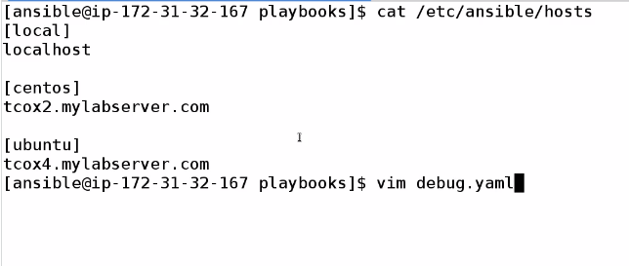

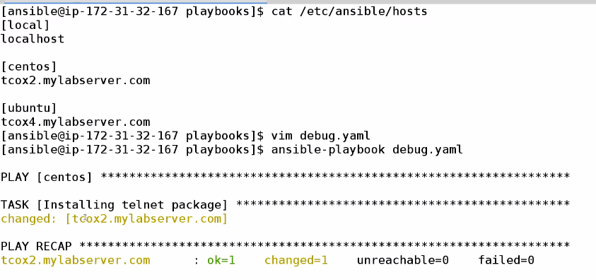

Not getting enough information , like package is updated or installed ,,or any misbehaving case

So for debugging purpuses we add

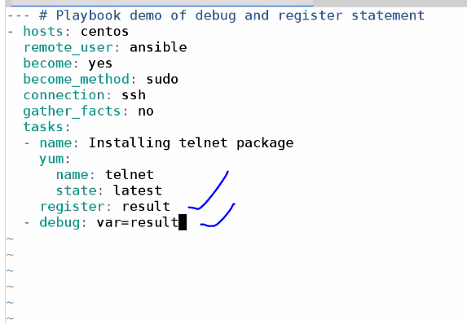

Now if we run the playbook now ,we will get lots of info

